

Contents

**Workflow** 1

**Users** 2

**Admin User** 2

**Data Entry Operators** 3

**Shift Incharge** 5

**Masters** 8

**1) Customer Master** 8

**2) Plot Master** 9

**3) Service Provider Master** 10

**4) Cargo Master** 11

**5) Equipment Master** 12

**6) Vessel Master** 13

**Entering Equipment Operational Data** 14

**Forms and Datalists** 16

**Forms** 16

**Datalists** 16

**Workflow**

Concerned officials can filter and download the approved data in required format

Shift Incharge approves the entered data

Data Entry Operator enters the data

**Users**

**Admin User**

Along with access to all the available actions of the application, admin also has access to edit the core of the application.

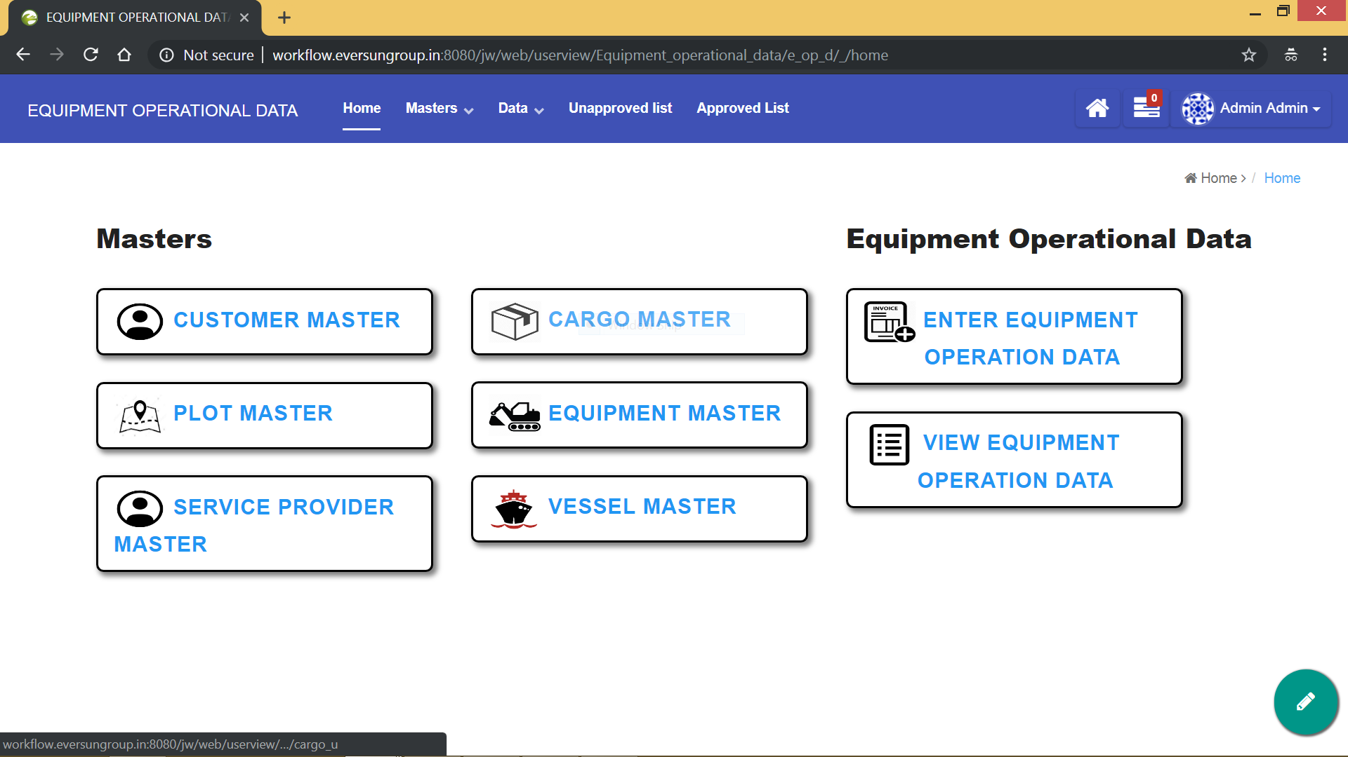

As shown in the screenshot above, the admin has access to

1. All masters
2. Enter and View the Equipment Operational Data
3. Unapproved list
4. Approved list
5. Edit the core of the application (forms, datalists, userviews)

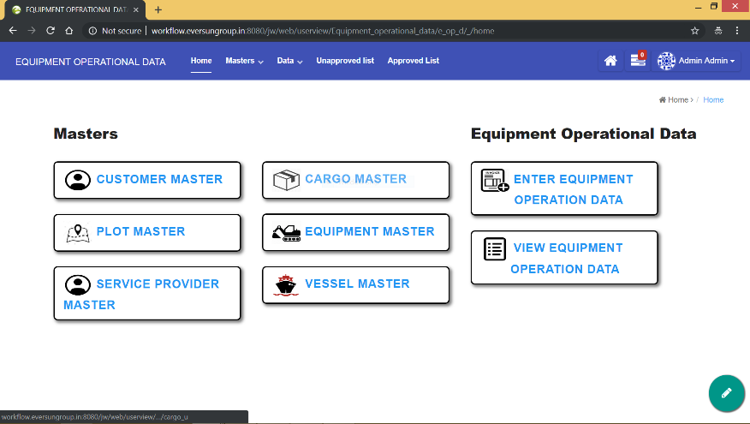Use this button to edit the core forms, datalists and userviews of the application.

**Data Entry Operators**

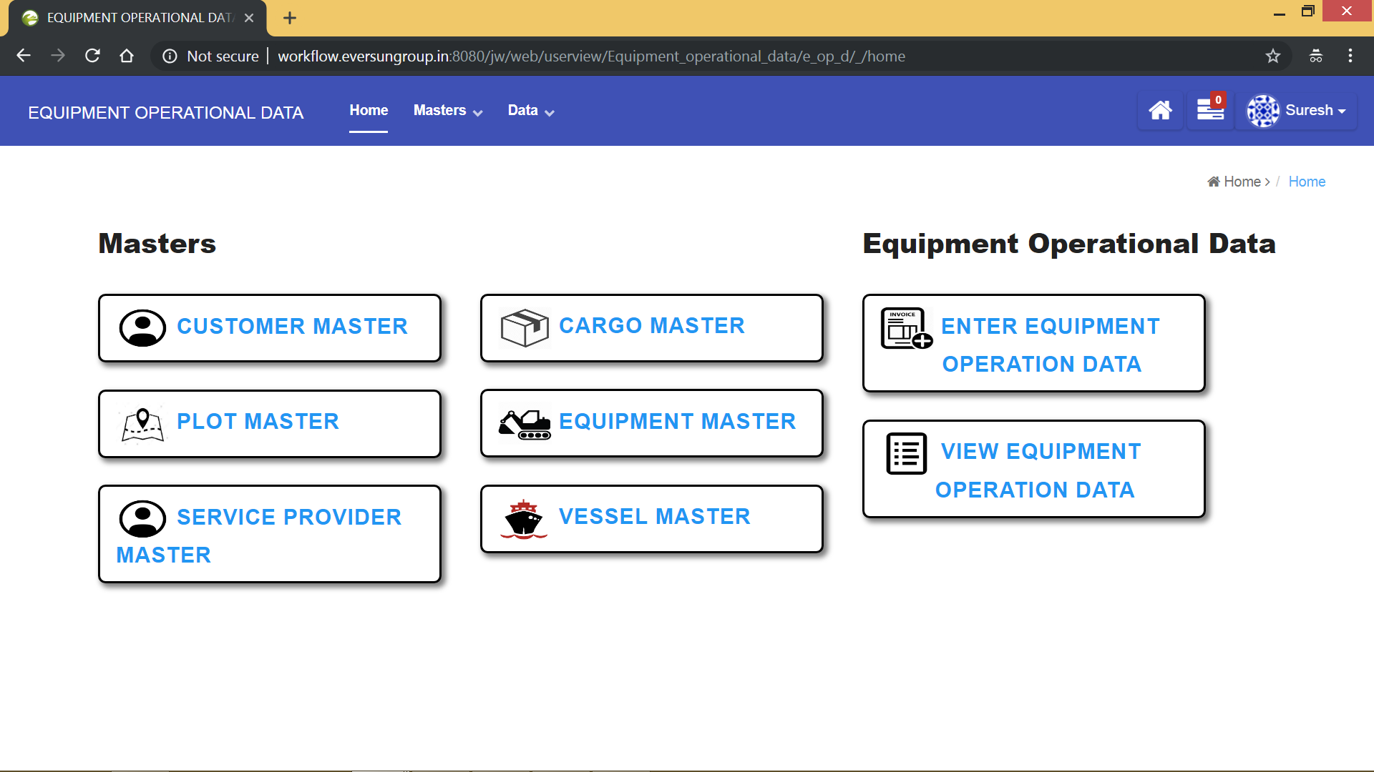

Homepage of Data Entry Operator

**Actions that can be performed by data entry operator**

1) Add and Edit data in masters.

2) Enter Equipment Operations Data.

3) View and Edit Equipment Operations Data.

4) Clarify the equipment operations data.

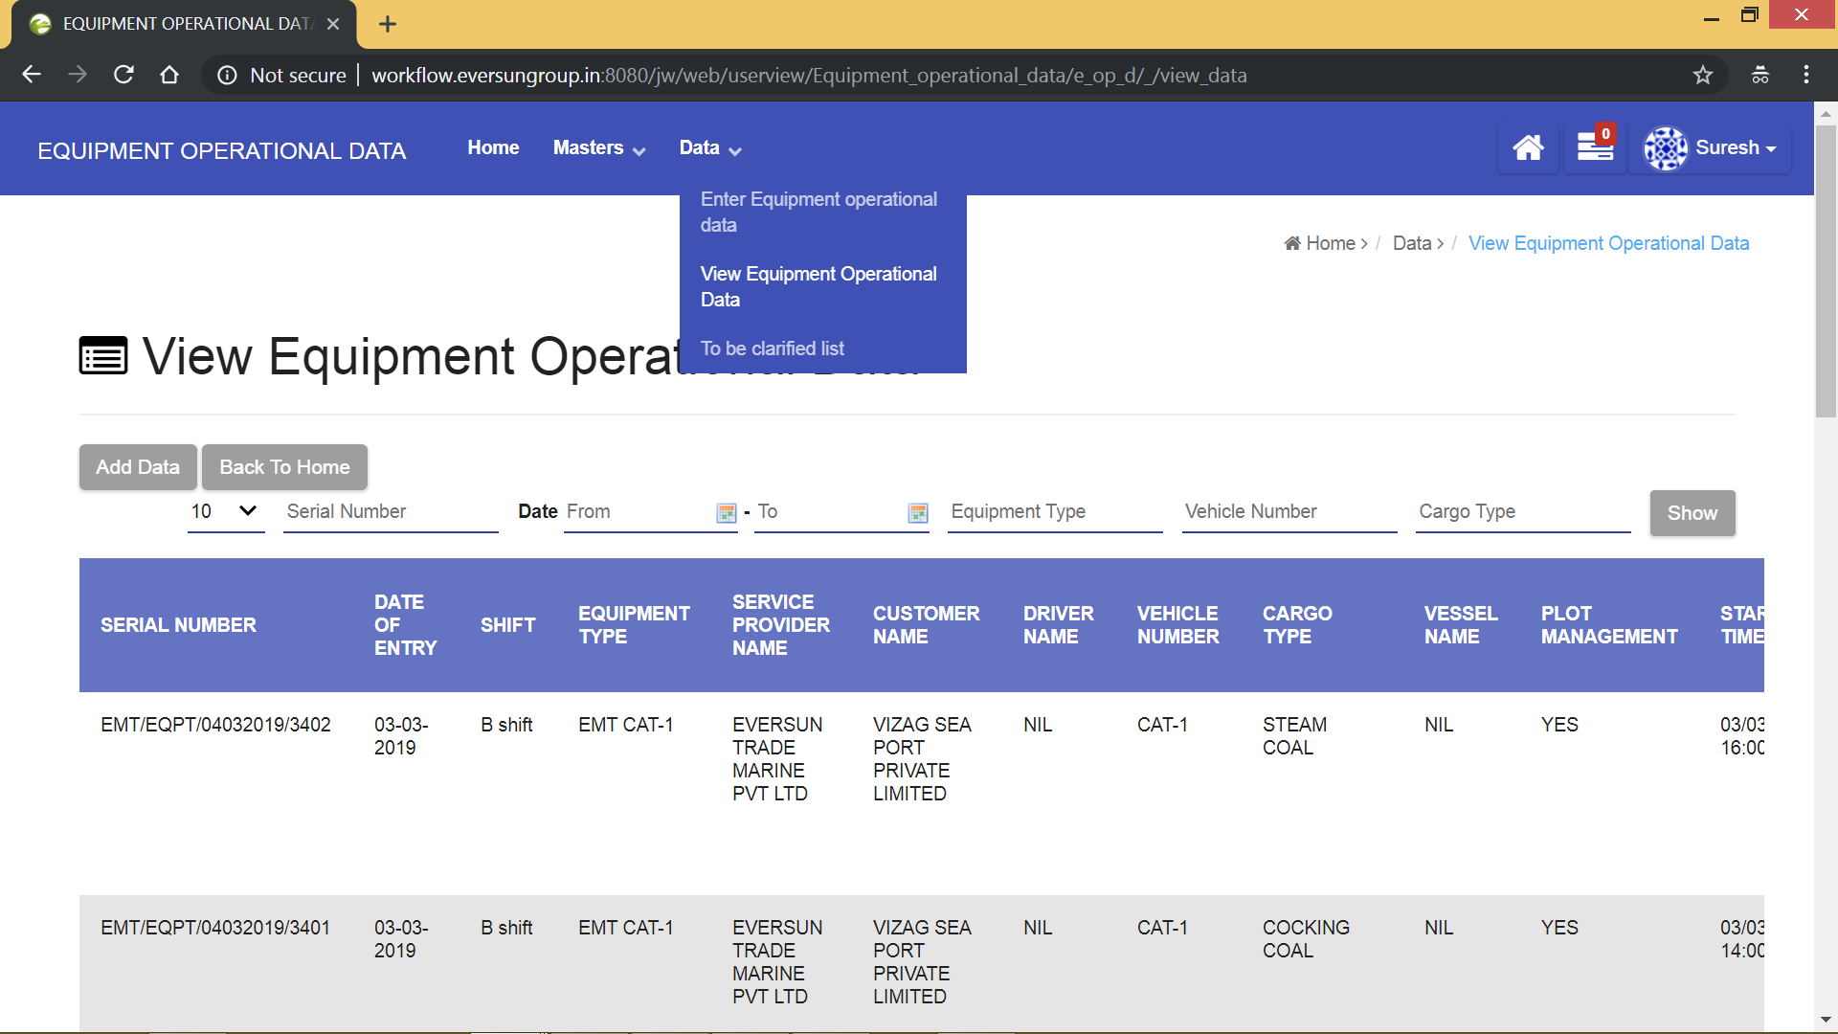Lists accessible to data entry operator

**Shift Incharge**

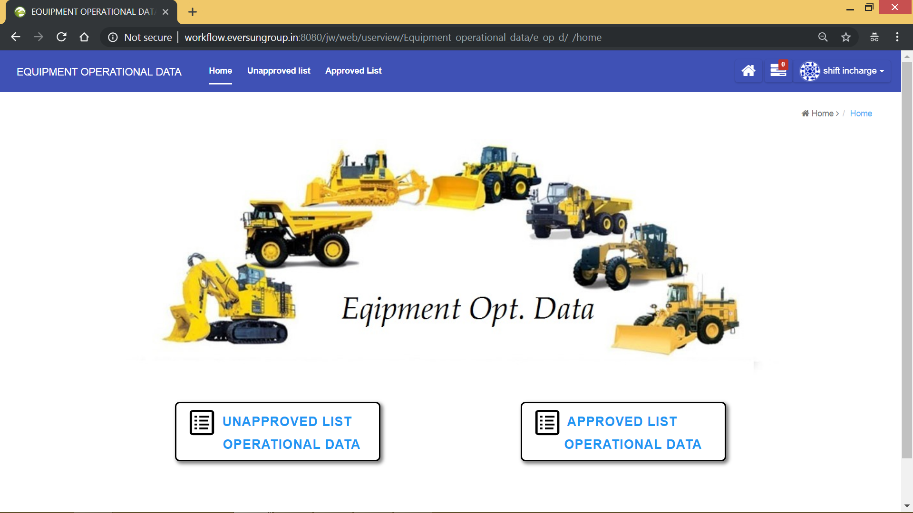

Shift incharge can view only the approved and unapproved list. His task is to approve the data entered by the data entry operator, so he can see only the approved and unapproved lists in his homepage. All the data that is approved goes to the approved list and the data that is yet to be approved stays in unapproved list. Also, there is a provision for the shift incharge to ask for clarification of data.

Data Entry Operator

Data reaches Approved list

Enters or changes data

If shift incharge requires clarification

On shift incharge Approval

Data reaches unapproved list

Data can be filtered and downloaded in required format

**Process**

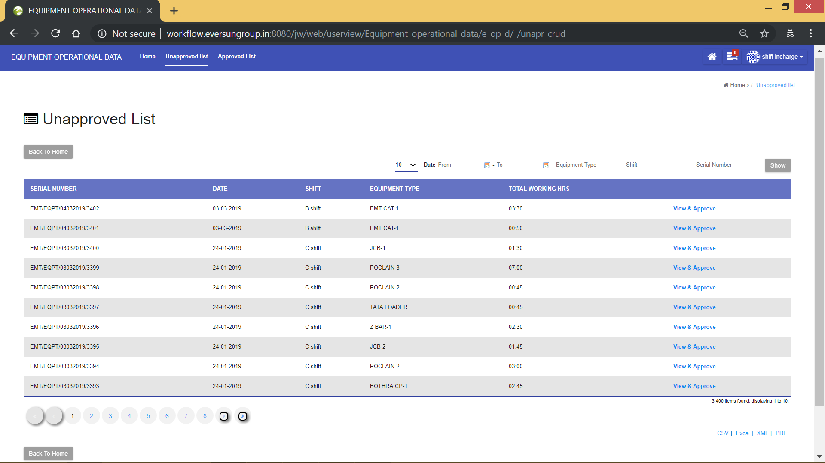

Click on **“View & Approve”** button in the unapproved list to set the status of the entry. The status of the document can either be **“Approved”** or **“Clarification Required”** as shown in below screenshot

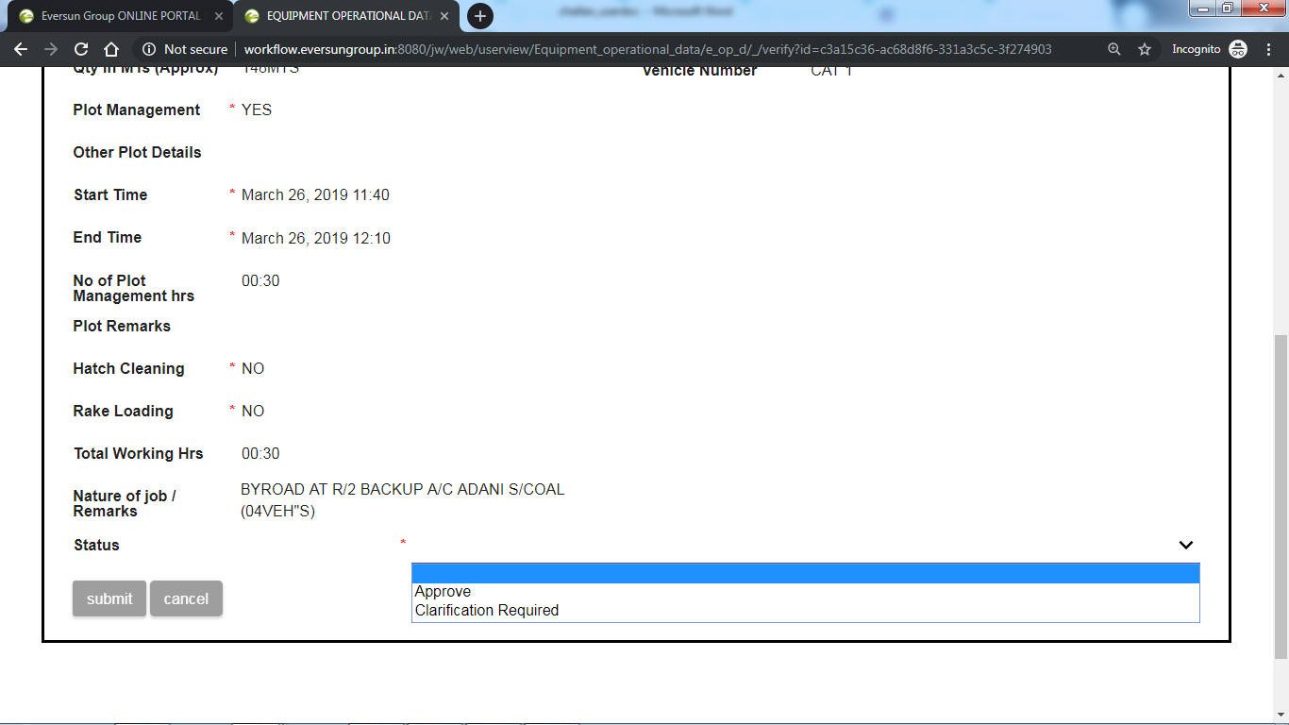

**Status : Approve**

Once the data is verified, then it can be approved by setting status to approve and then submit it. The data once approved is removed from the **“unapproved list”** and is sent **“approved list”.**

**Status: Clarification Required**

If there are any errors in the data, then it can be clarified by setting status to **“Clarification Required”,** comment the reason for clarification and then submit it. This data is sent to “data entry operator” for it to be clarified. After it is clarified, it is again sent back to unapproved list.

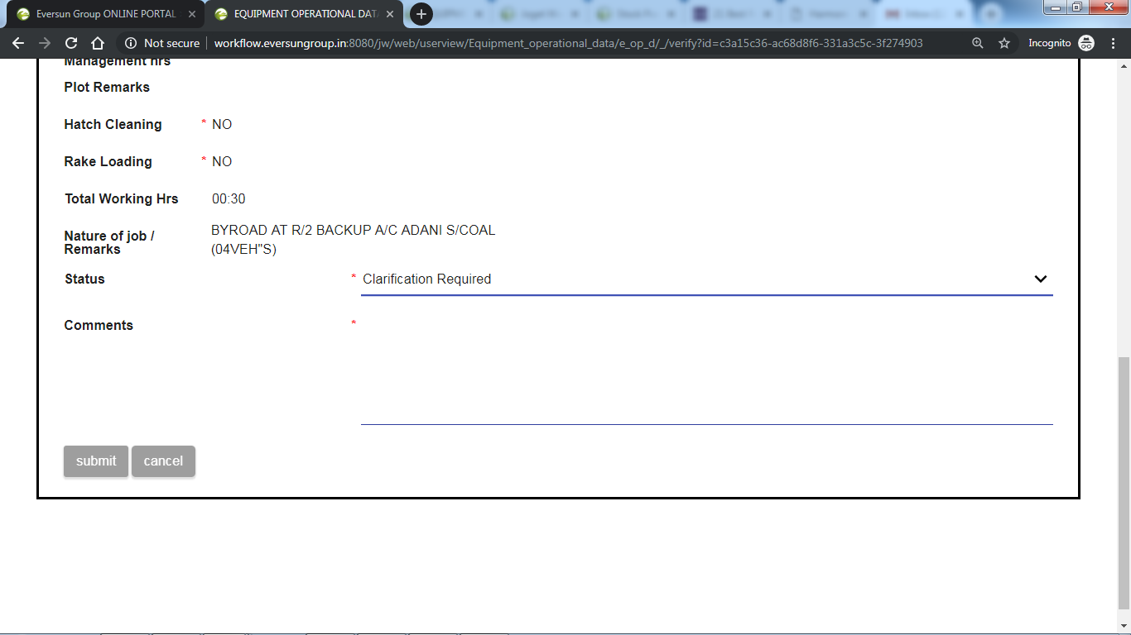

The approved list looks as follows

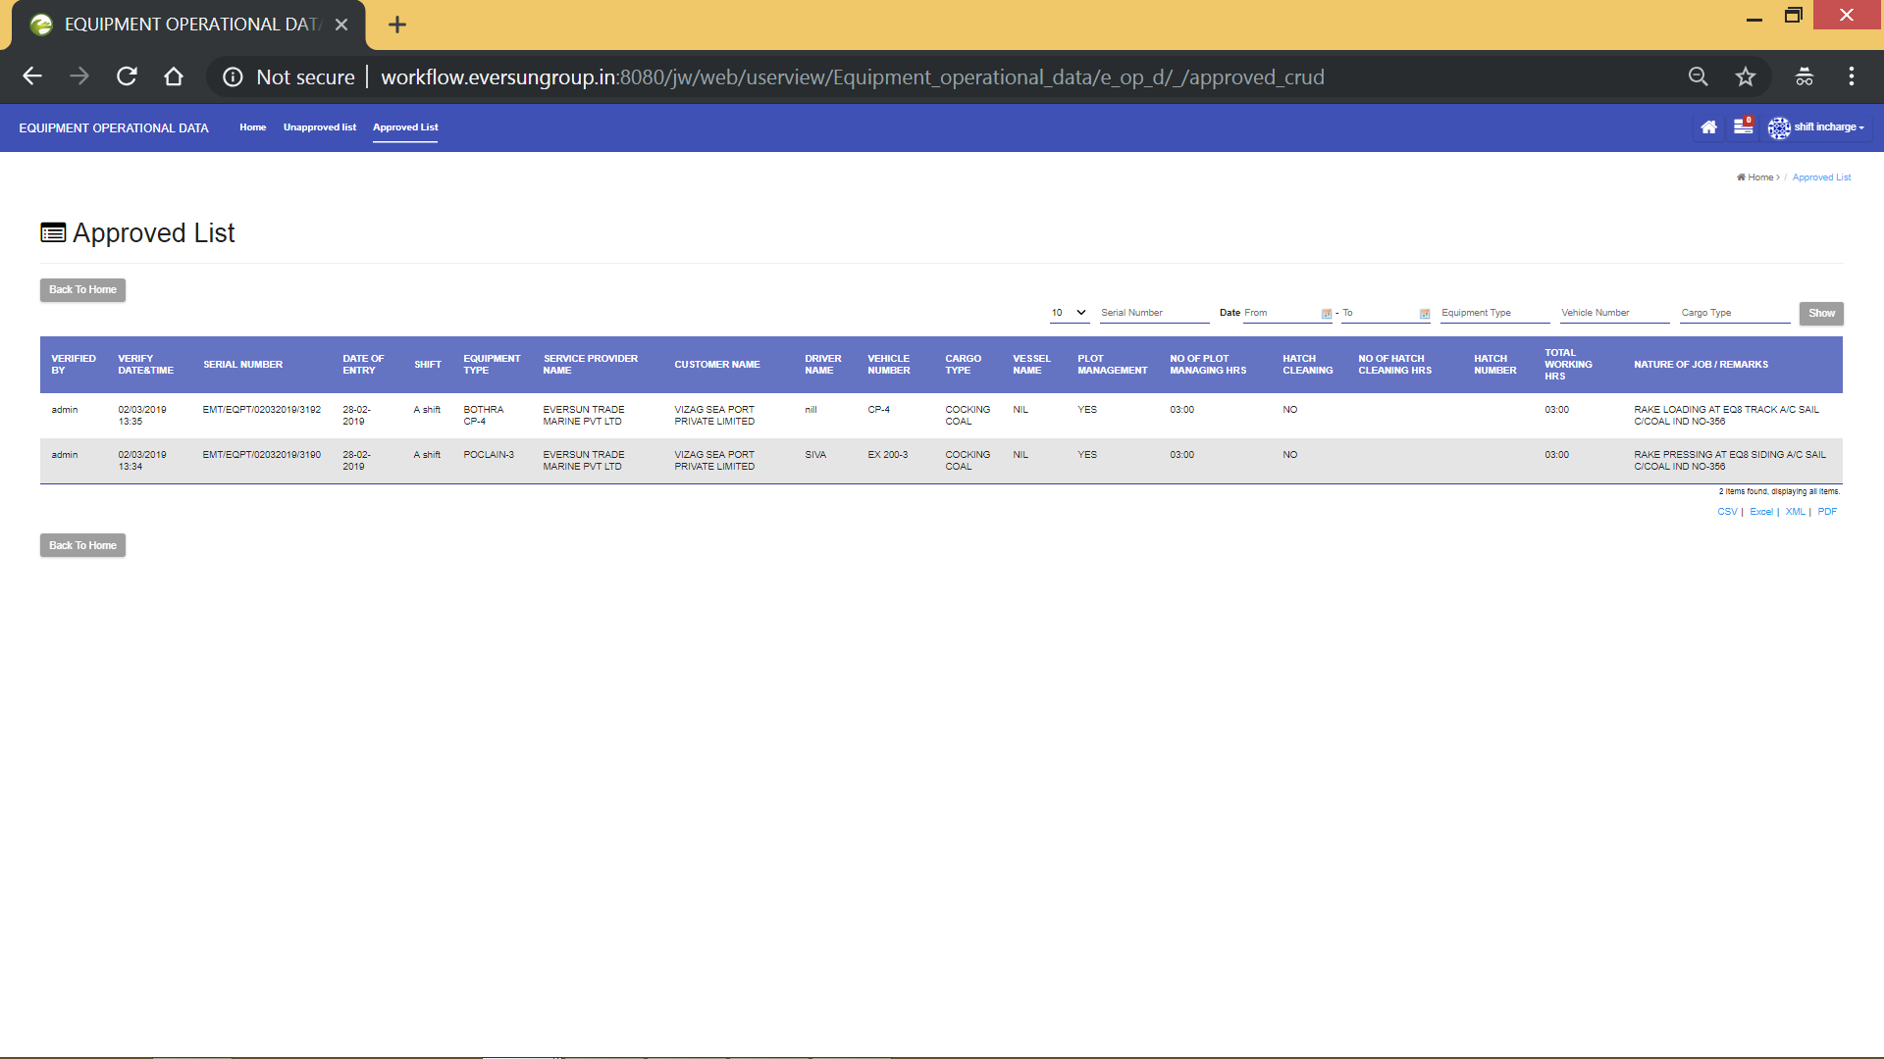

The approved data can be downloaded in the required format by clicking on respective format as shown above.

**Masters**

**1) Customer Master**

Click on “Customer master” from home page or from “masters” dropdown. Then you will see a page like in the image below.

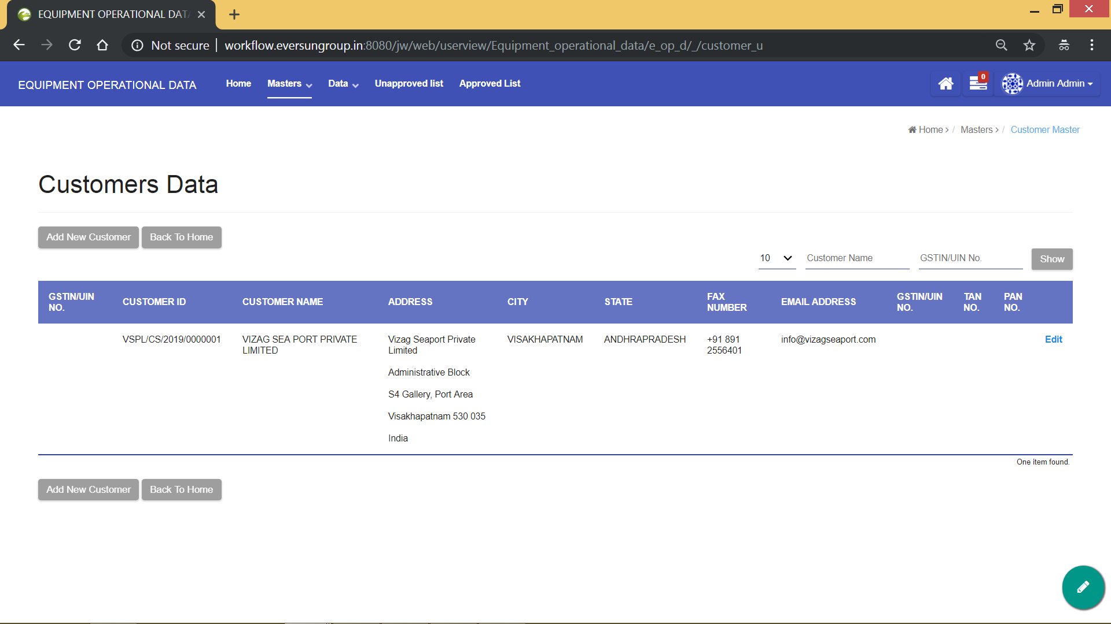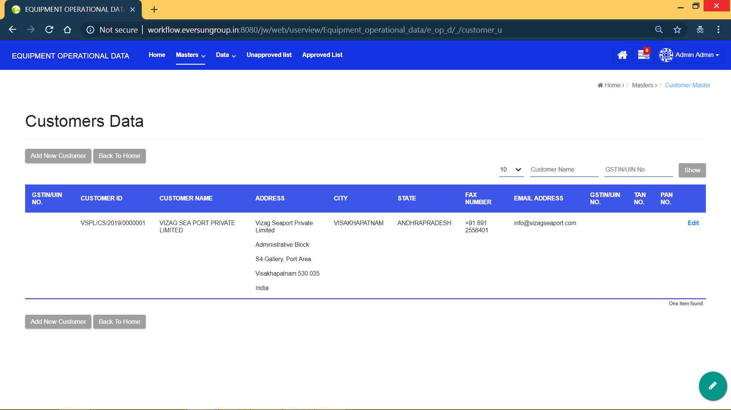

Here you can do the following things

1. Edit the existing customer details using **“Edit”** button, which is to the right of each data.
2. Go back to home page using **“Back To Home”** button, which is to the right of each data.
3. Search among the available customers, using the available filters on the top right corner of the screen.
4. If the required customer is not available in the list, you can always come here and add new customer data using **“Add New Customer”** button, which is to the top and bottom of the customer’s data list. The below screenshot shows the customer registration form, which appears when **“Add New Customer”** is clicked.

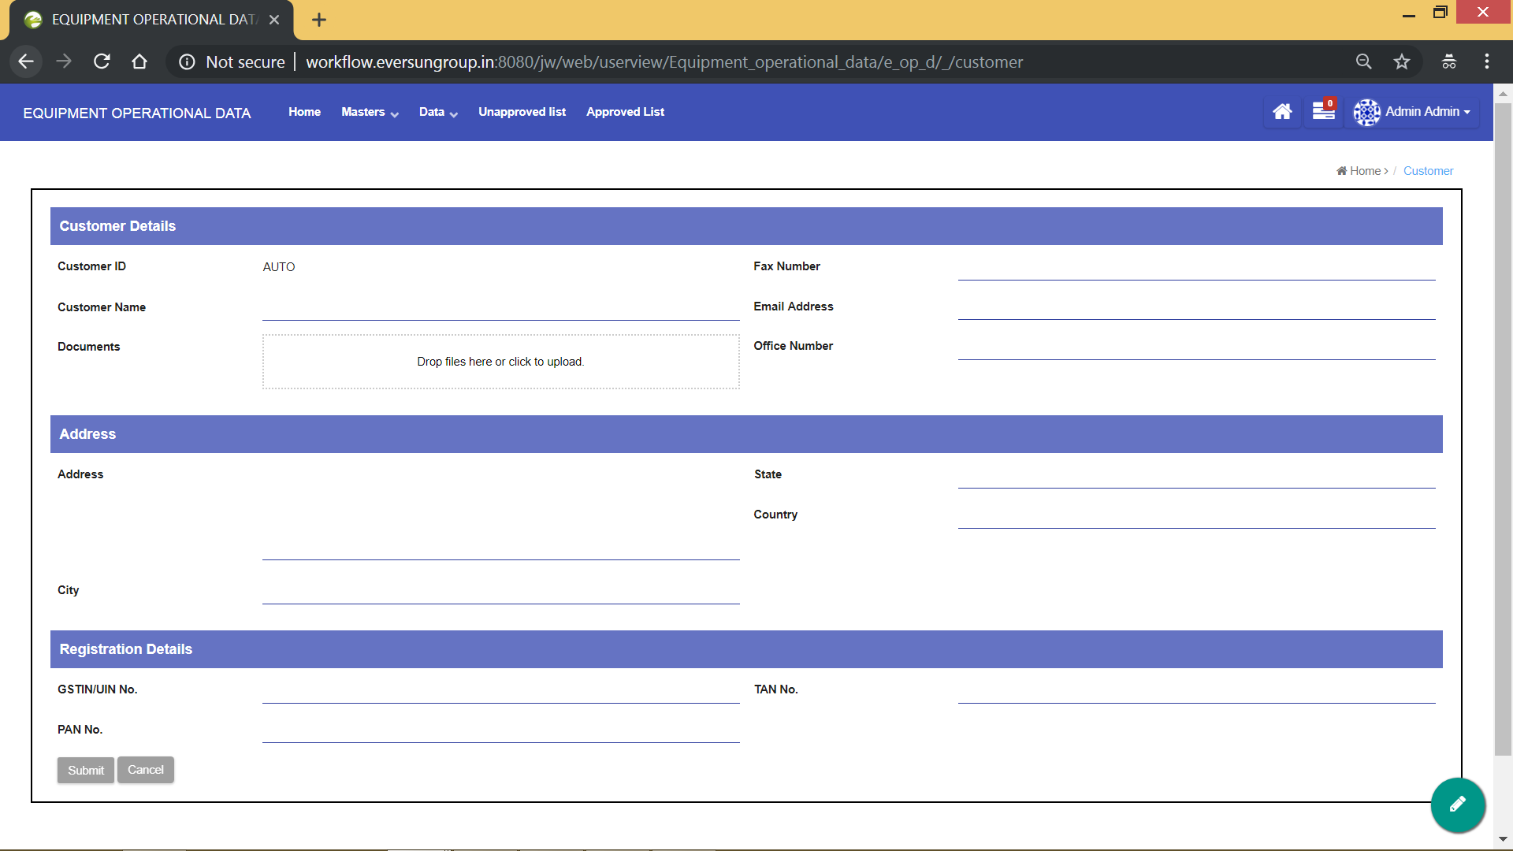

Fill all the details of the new customer and click on **“Submit”** to add the new customer.

**2) Plot Master**

Click on “Plot master” from home page or from “masters” dropdown. Then you will see a page like in the image below.

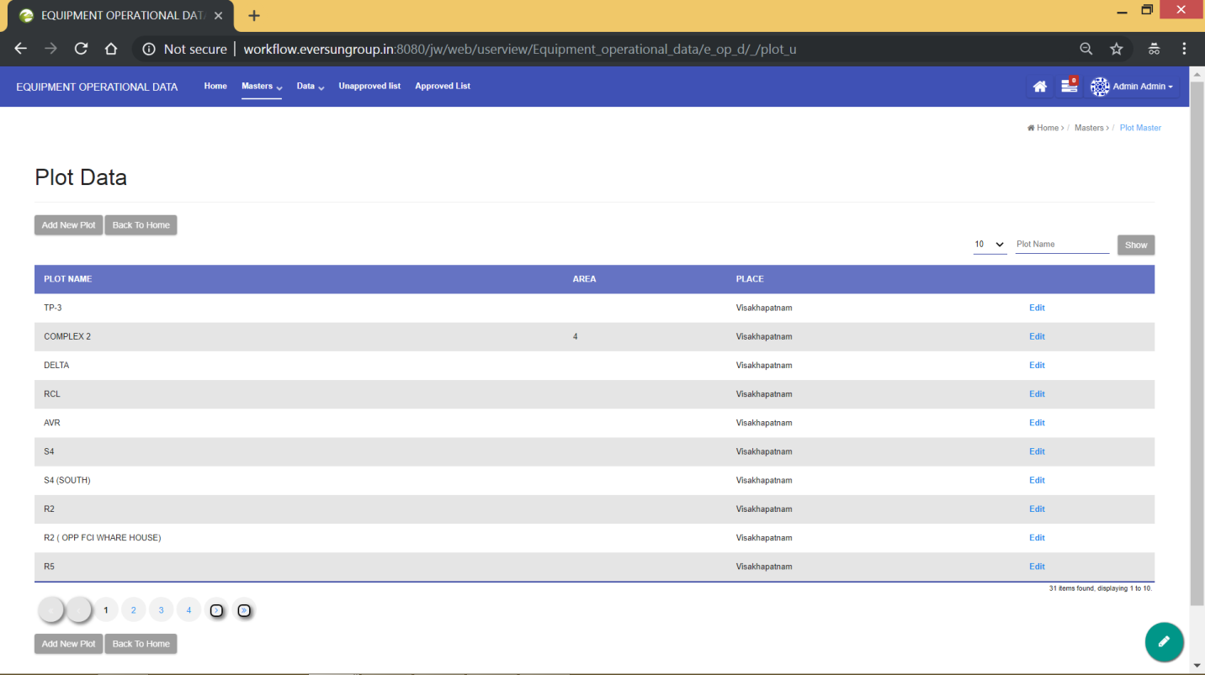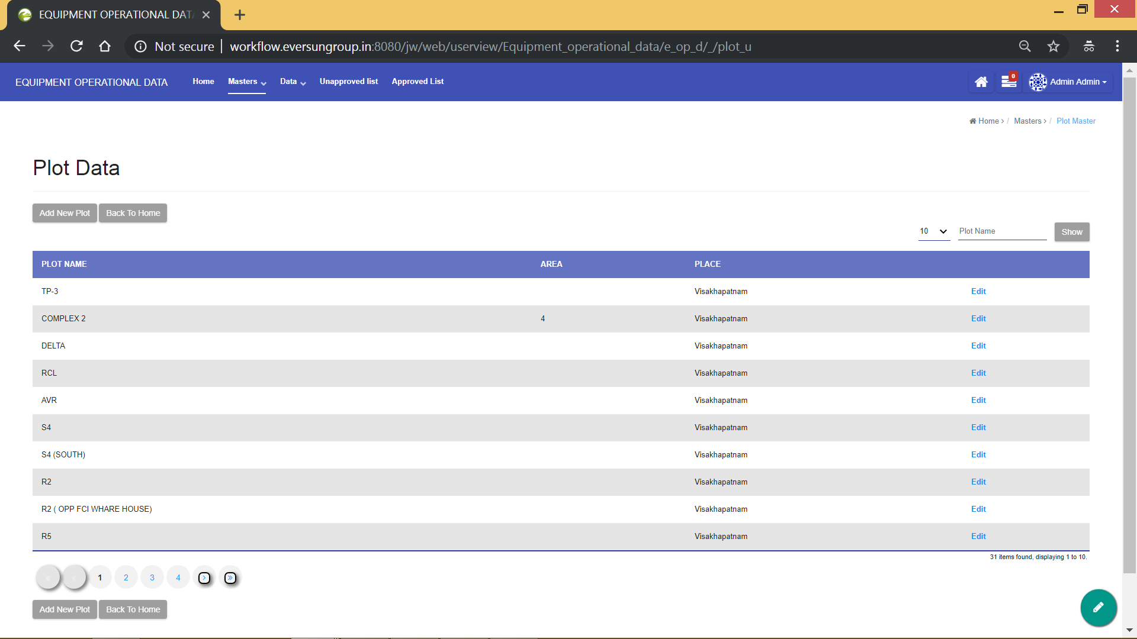

Here you can do the following things

1. Edit the existing plot details using **“Edit”** button, which is to the right of each data.
2. Go back to home page using **“Back To Home”** button, which is to the right of each data.
3. Search among the available plots, using the available filters on the top right corner of the screen.
4. If the required plot is not available in the list, you can always come here and add new plot data using **“Add New Plot”** button, which is to the top and bottom of the plot’s data list. The below screenshot shows the plot registration form, which appears when **“Add New Plot”** is clicked.

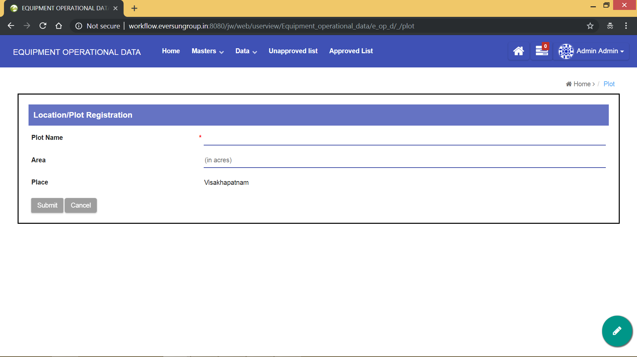

Fill all the details of the new plot and click on **“Submit”** to add the new plot.

**3) Service Provider Master**

Click on “Service Provider Master” from home page or from “masters” dropdown. Then you will see a page like in the image below.

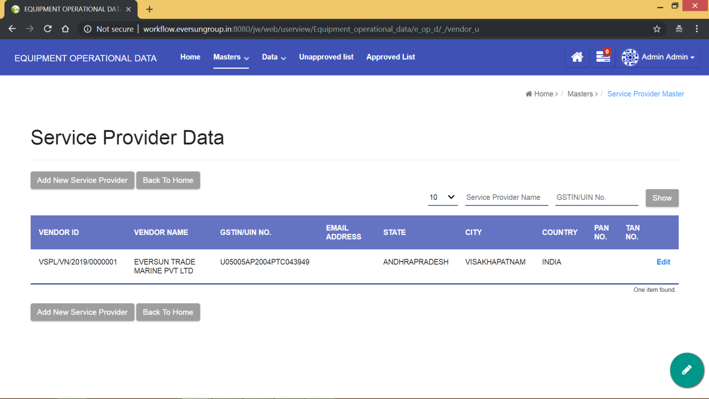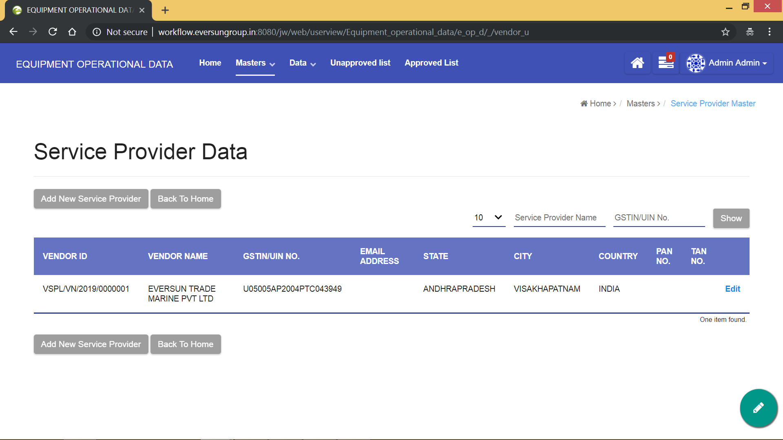

Here you can do the following things

1. Edit the existing service provider details using **“Edit”** button, which is to the right of each data.
2. Go back to home page using **“Back To Home”** button, which is to the right of each data.
3. Search among the available service providers, using the available filters on the top right corner of the screen.
4. If the required service provider is not available in the list, you can always come here and add new service provider data using **“Add New Service Provider”** button, which is to the top and bottom of the service provider’s data list. The below screenshot shows the service provider registration form, which appears when **“Add New Service Provider”** is clicked.

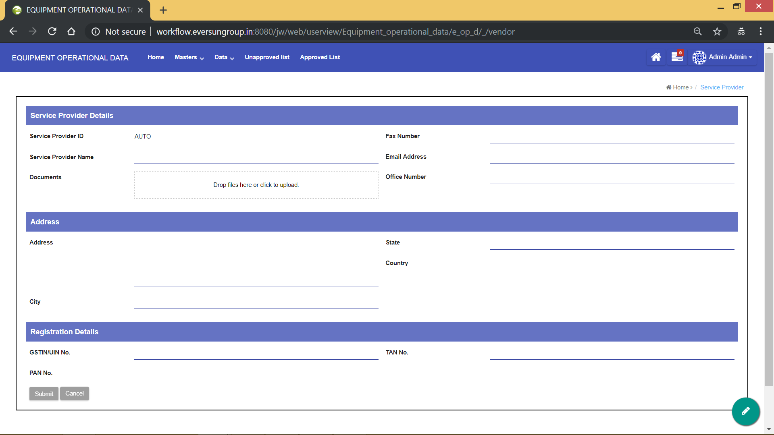

Fill all the details of the new service provider and click on **“Submit”** to add the new service provider.

**4) Cargo Master**

Click on “Cargo Master” from home page or from “masters” dropdown. Then you will see a page like in the image below.

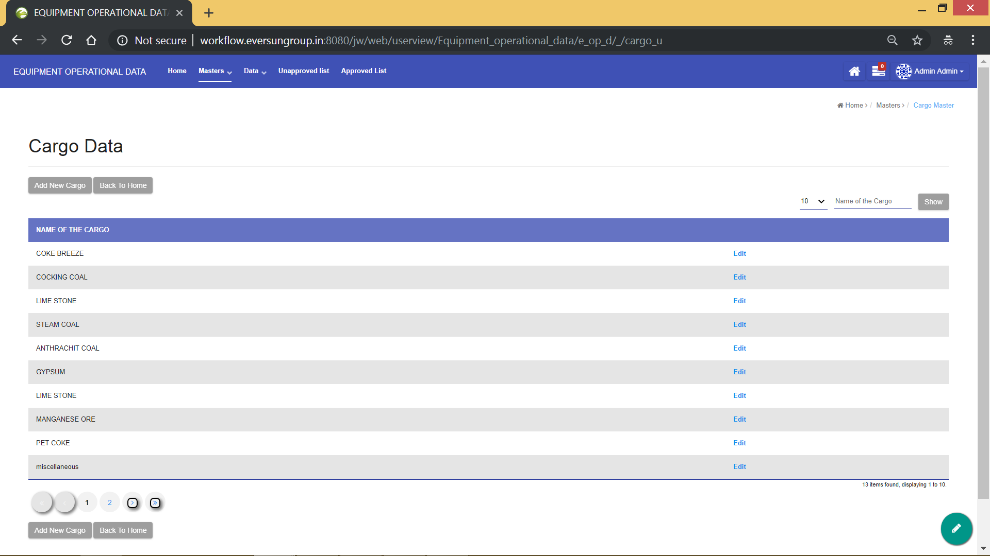

Here you can do the following things

1. Edit the existing cargo details using **“Edit”** button, which is to the right of each data.
2. Go back to home page using **“Back To Home”** button, which is to the right of each data.
3. Search among the available cargo types, using the available filters on the top right corner of the screen.
4. If the required cargo type is not available in the list, you can always come here and add new cargo data using **“Add New Cargo”** button, which is to the top and bottom of the cargo’s data list. The below screenshot shows the cargo registration form, which appears when **“Add New Cargo”** is clicked.

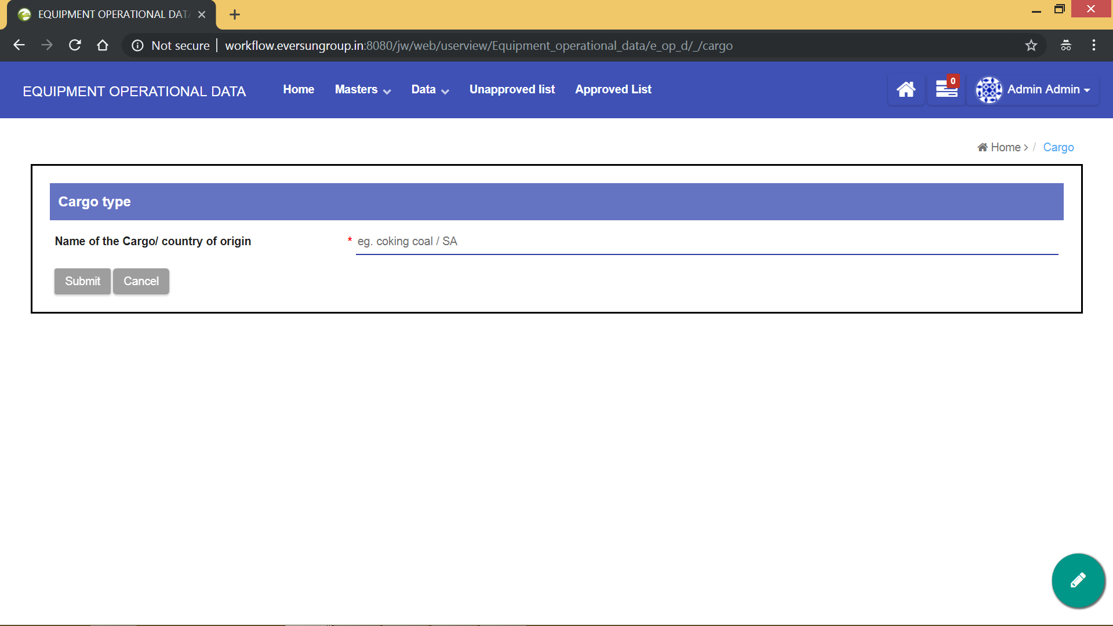

Fill all the details of the new cargo and click on **“Submit”** to add the new cargo.

**5) Equipment Master**

Click on “Equipment Master” from home page or from “masters” dropdown. Then you will see a page like in the image below.

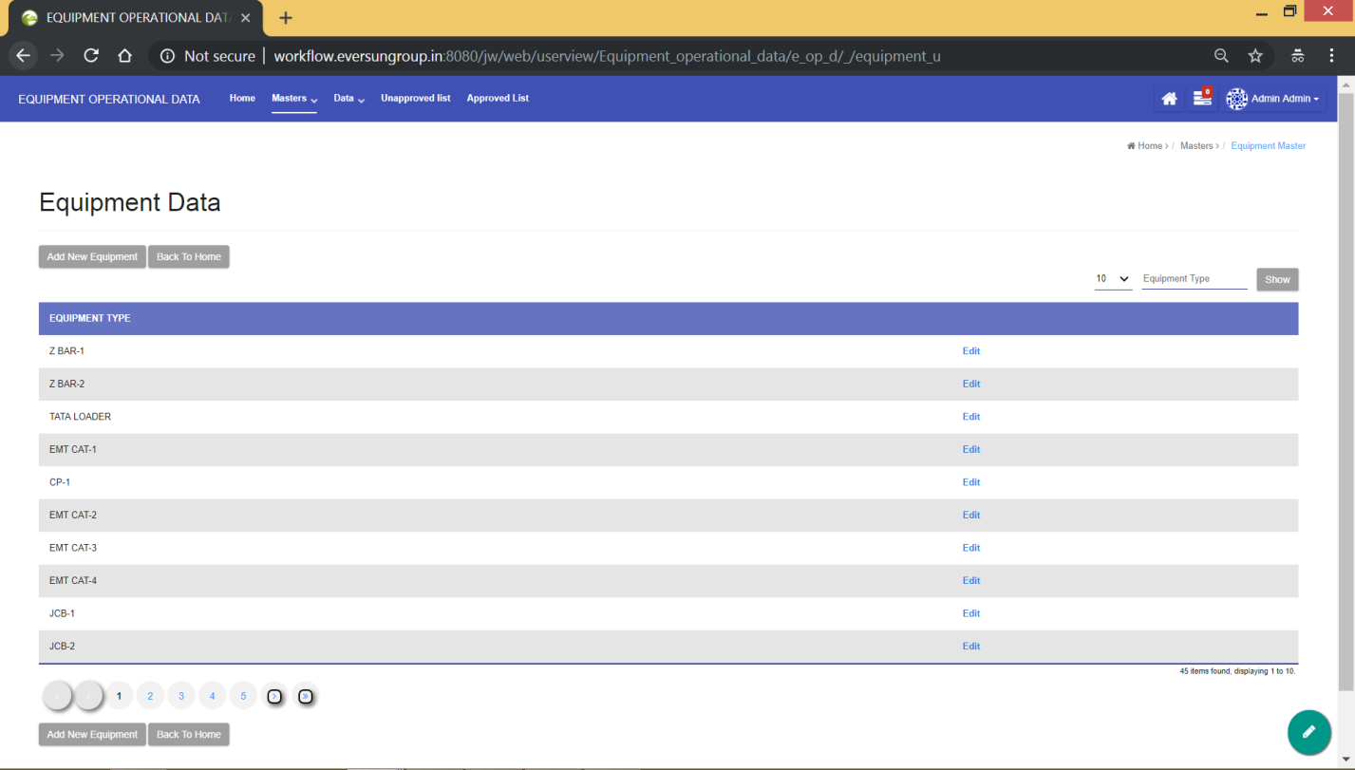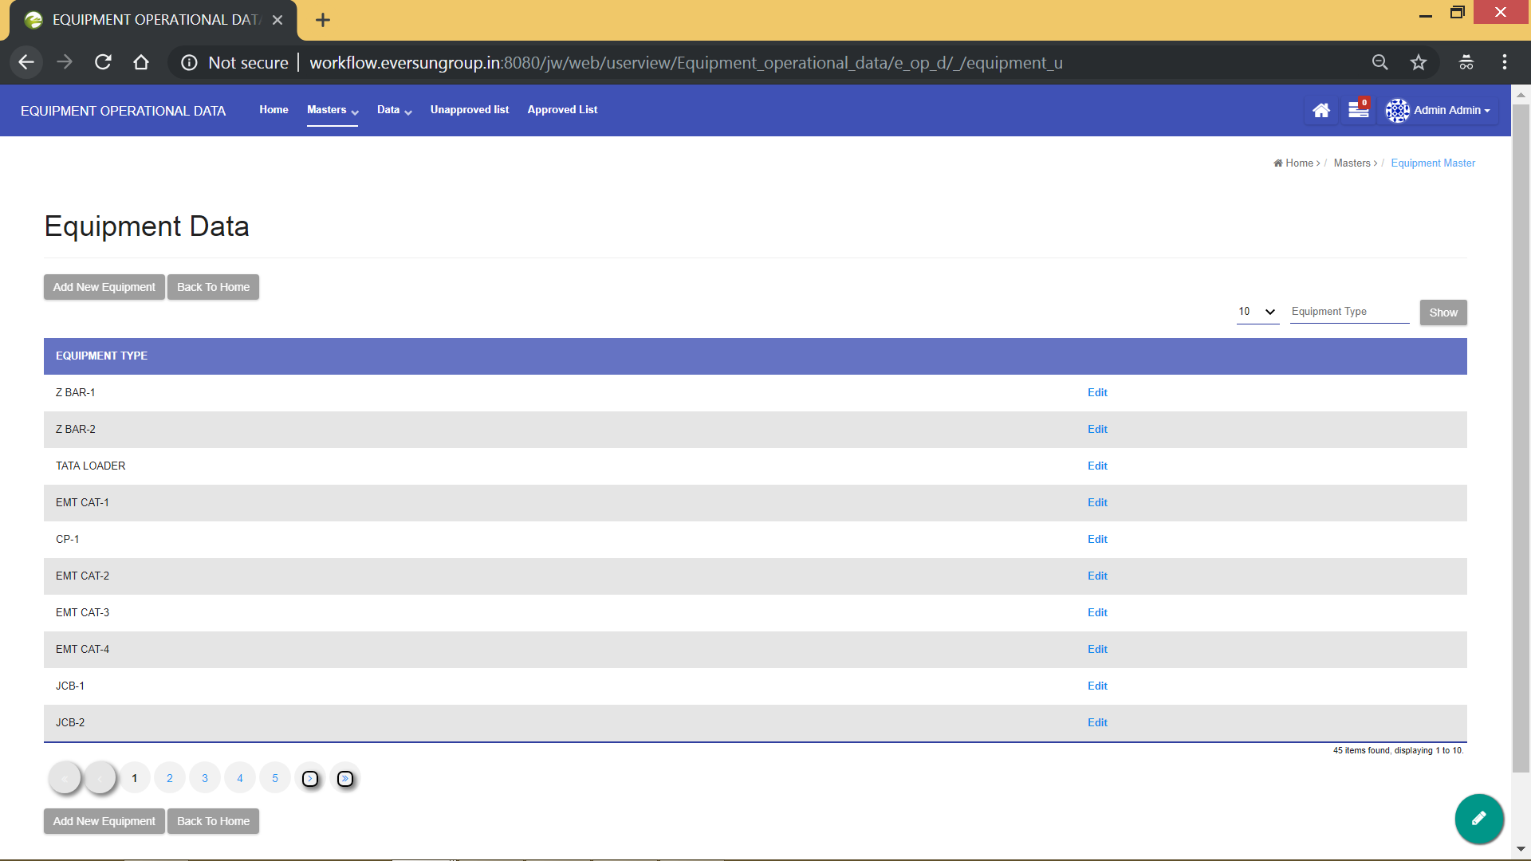

Here you can do the following things

1. Edit the existing equipment details using **“Edit”** button, which is to the right of each data.
2. Go back to home page using **“Back To Home”** button, which is to the right of each data.
3. Search among the available equipment’s, using the available filters on the top right corner of the screen.
4. If the required equipment is not available in the list, you can always come here and add new equipment data using **“Add New Equipment”** button, which is to the top and bottom of the equipment’s data list. The below screenshot shows the equipment registration form, which appears when **“Add New Equipment”** is clicked.

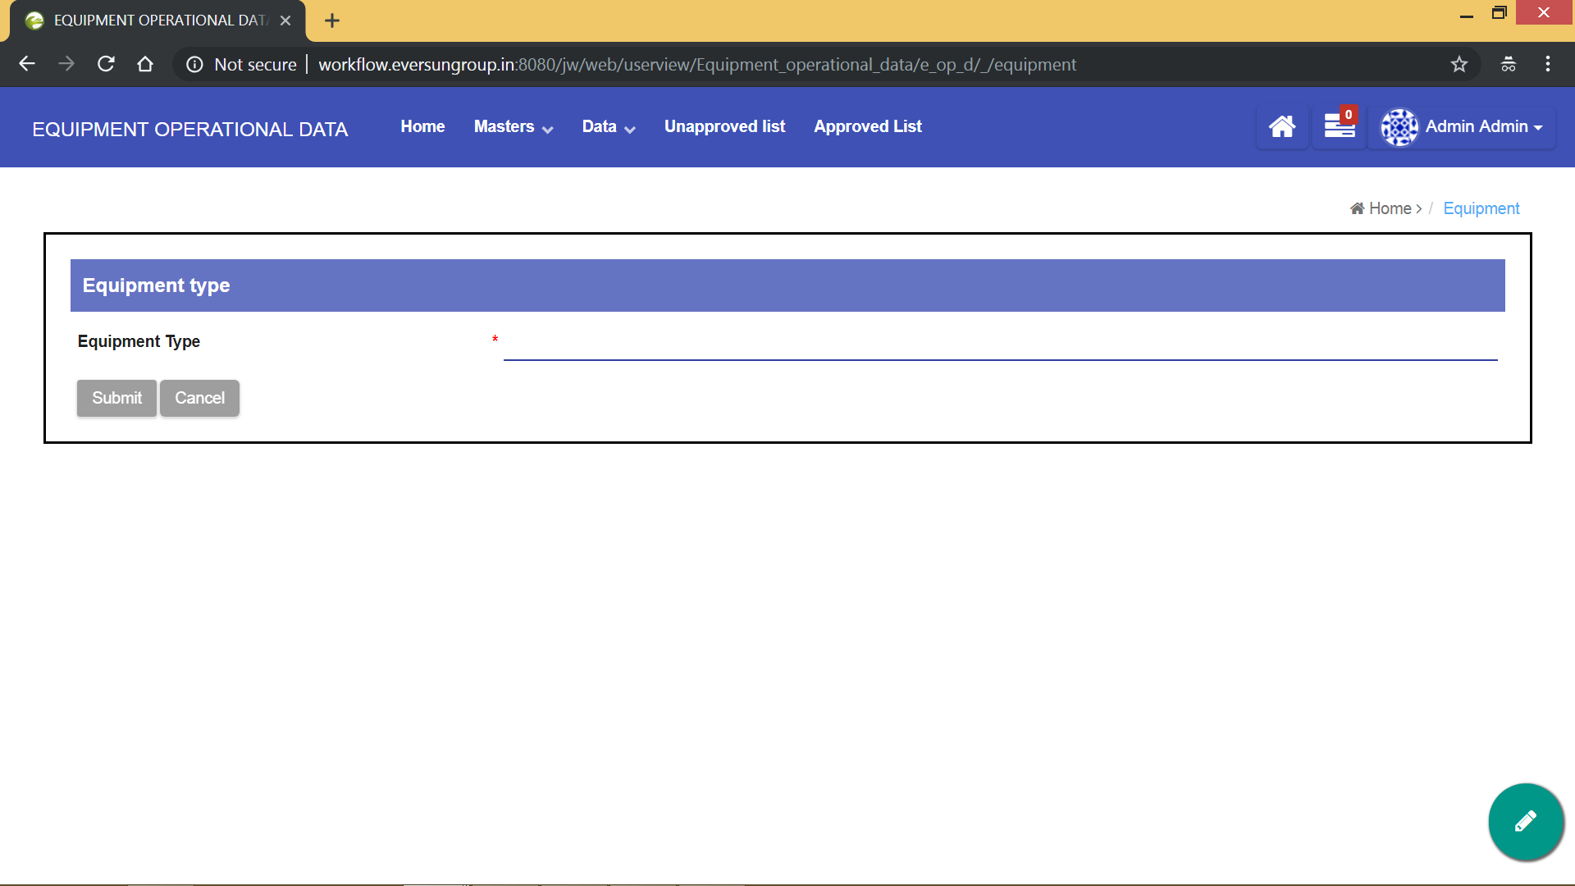

Fill all the details of the new equipment and click on **“Submit”** to add the new equipment.

**6) Vessel Master**

Click on “Vessel Master” from home page or from “masters” dropdown. Then you will see a page like in the image below.

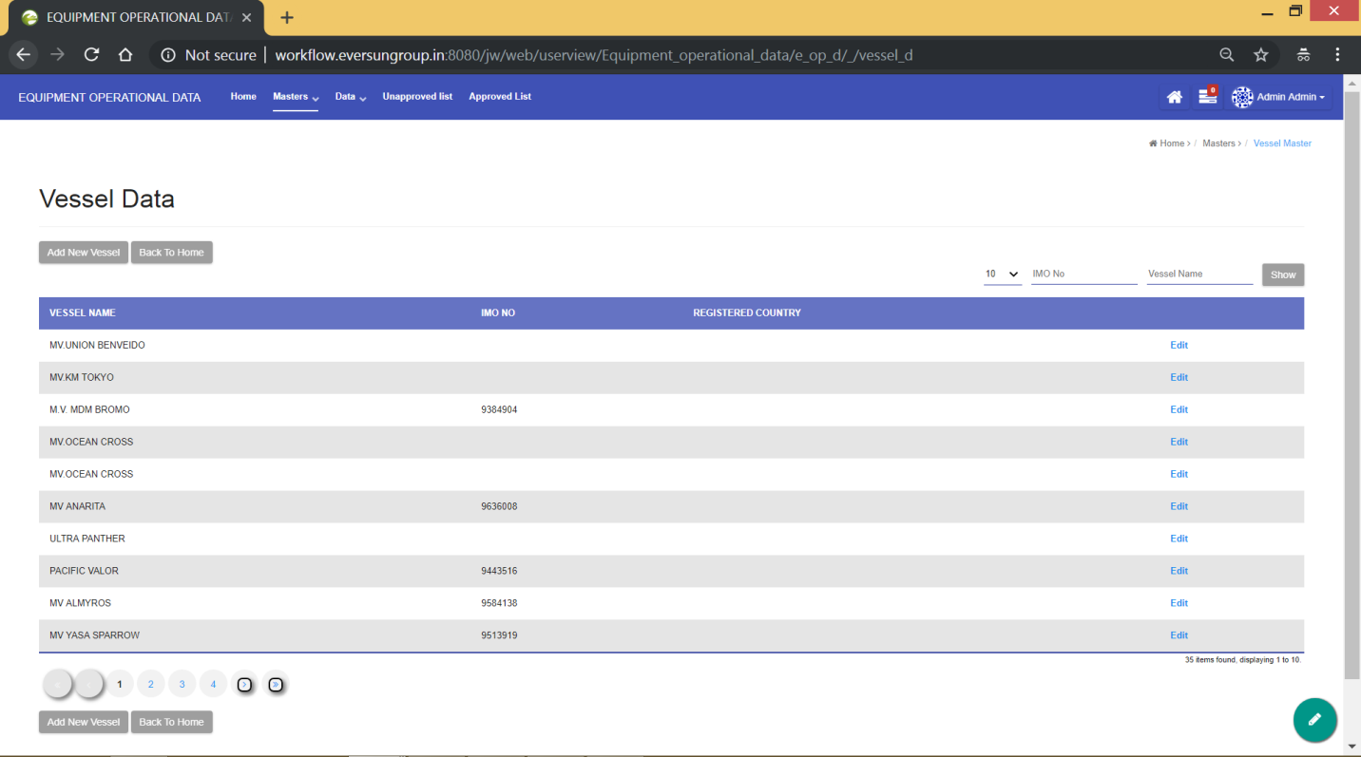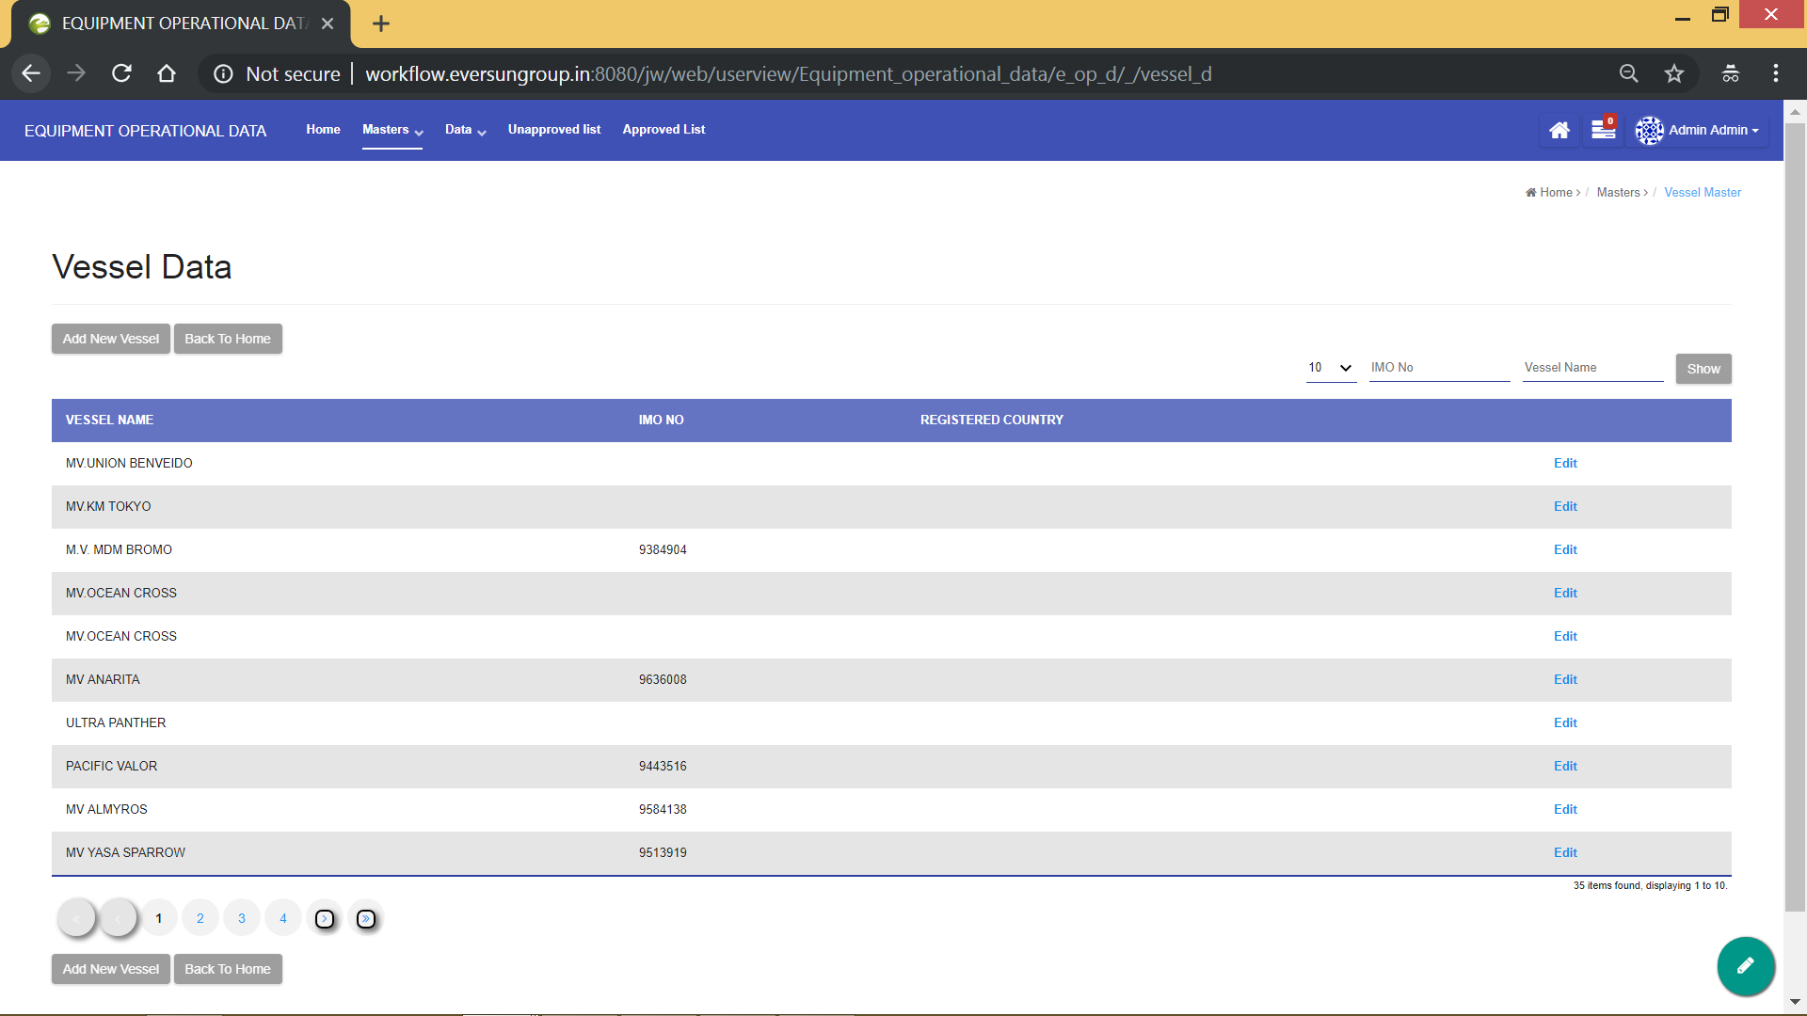

Here you can do the following things

1. Edit the existing vessel details using **“Edit”** button, which is to the right of each data.
2. Go back to home page using **“Back To Home”** button, which is to the right of each data.
3. Search among the available vessels, using the available filters on the top right corner of the screen.
4. If the required vessel is not available in the list, you can always come here and add new vessel data using **“Add New Vessel”** button, which is to the top and bottom of the vessels’s data list. The below screenshot shows the vessel data form, which appears when **“Add New Vessel”** is clicked.

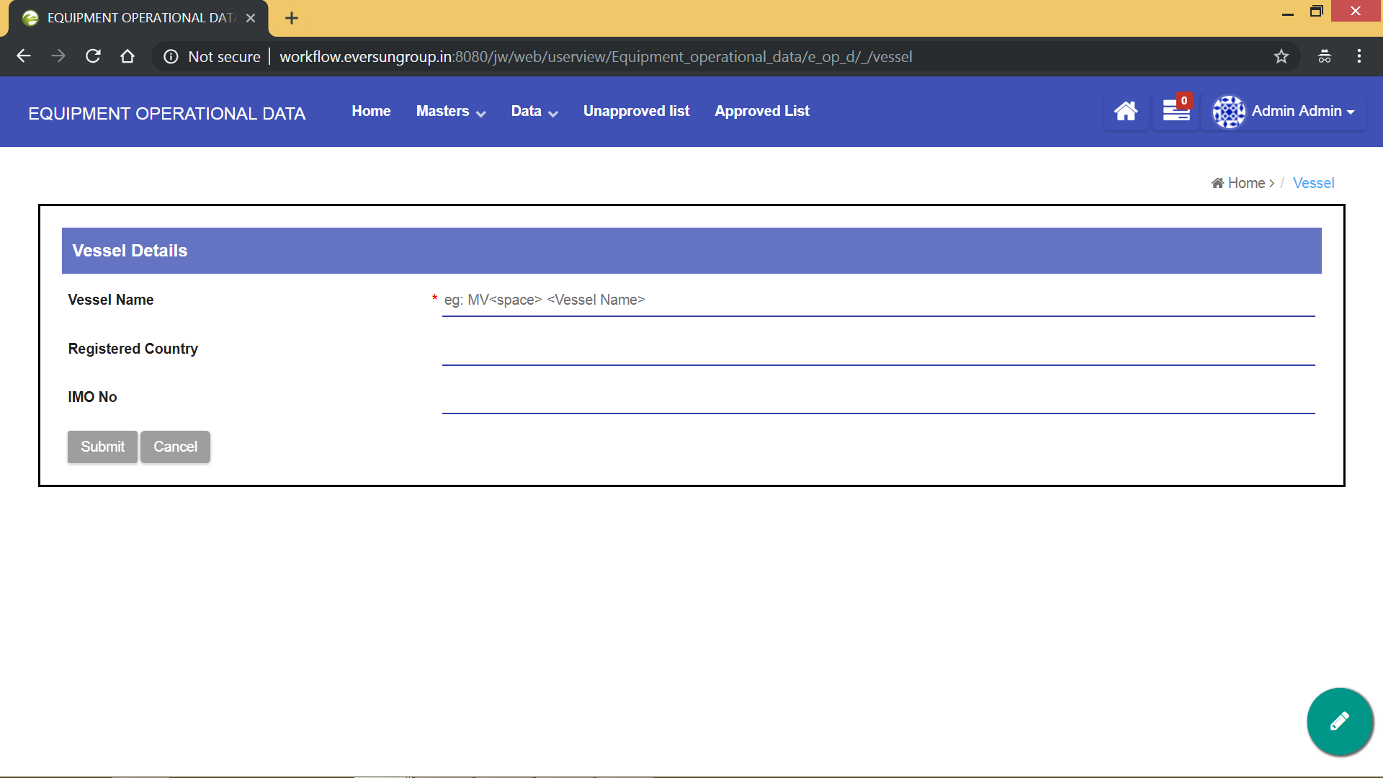

Fill all the details of the new vessel and click on **“Submit”** to add the new vessel.

**Entering Equipment Operational Data**

Click on “ENTER EQUIPMENT OPERATIONAL DATA” from home page or from “Data” dropdown. Then you will see a page like in the image below.

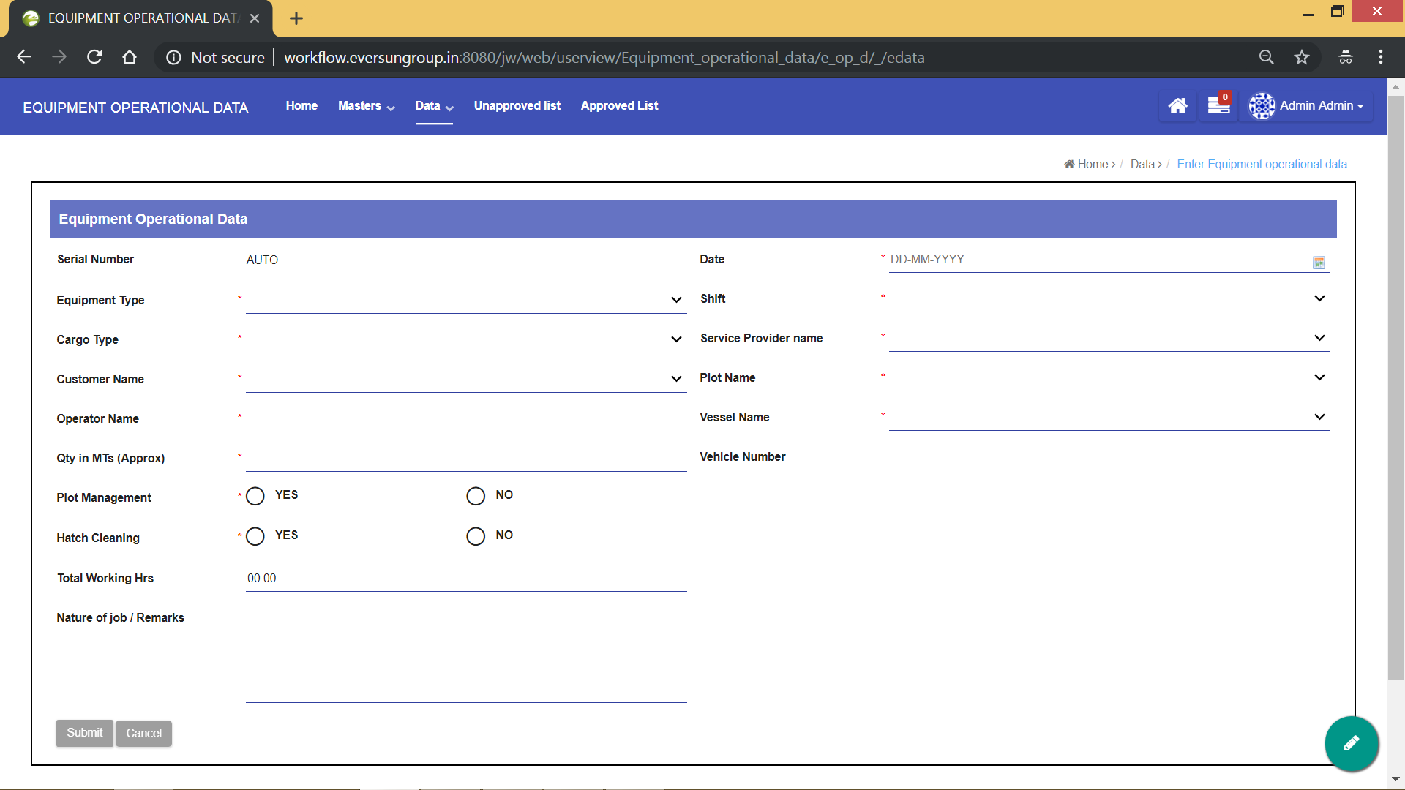

Fill all the mandatory details and click on **“Submit”** to add the equipment operational data. After submitting the form, the data will be added to the list and the user will automatically be redirected to the below page.

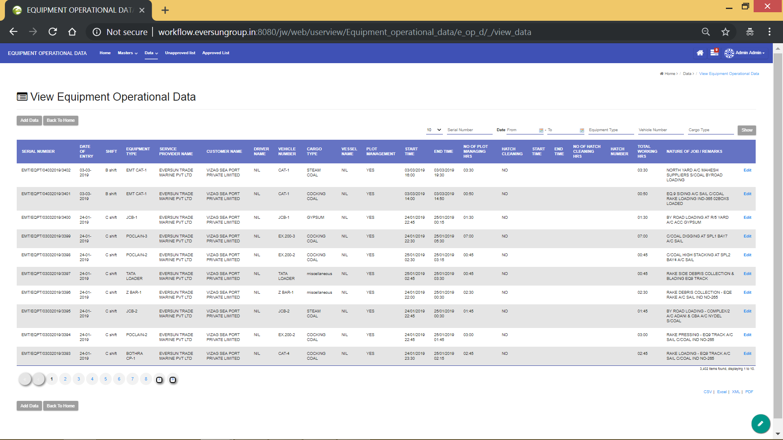

In the above page, you can do the following things

1. Edit the existing data using **“Edit”** button, which is to the right of each data.
2. Go back to home page using **“Back To Home”** button, which is to the right of each data.
3. Search among the available entries, using the available filters on the top right corner of the screen.
4. Add new data using **“Add Data”** button, which is to the top and bottom of the operation’s data list.

The below page can be accessed from the “Data” dropdown. The below list consists of all the entries which are marked by Shift Incharge for clarification.

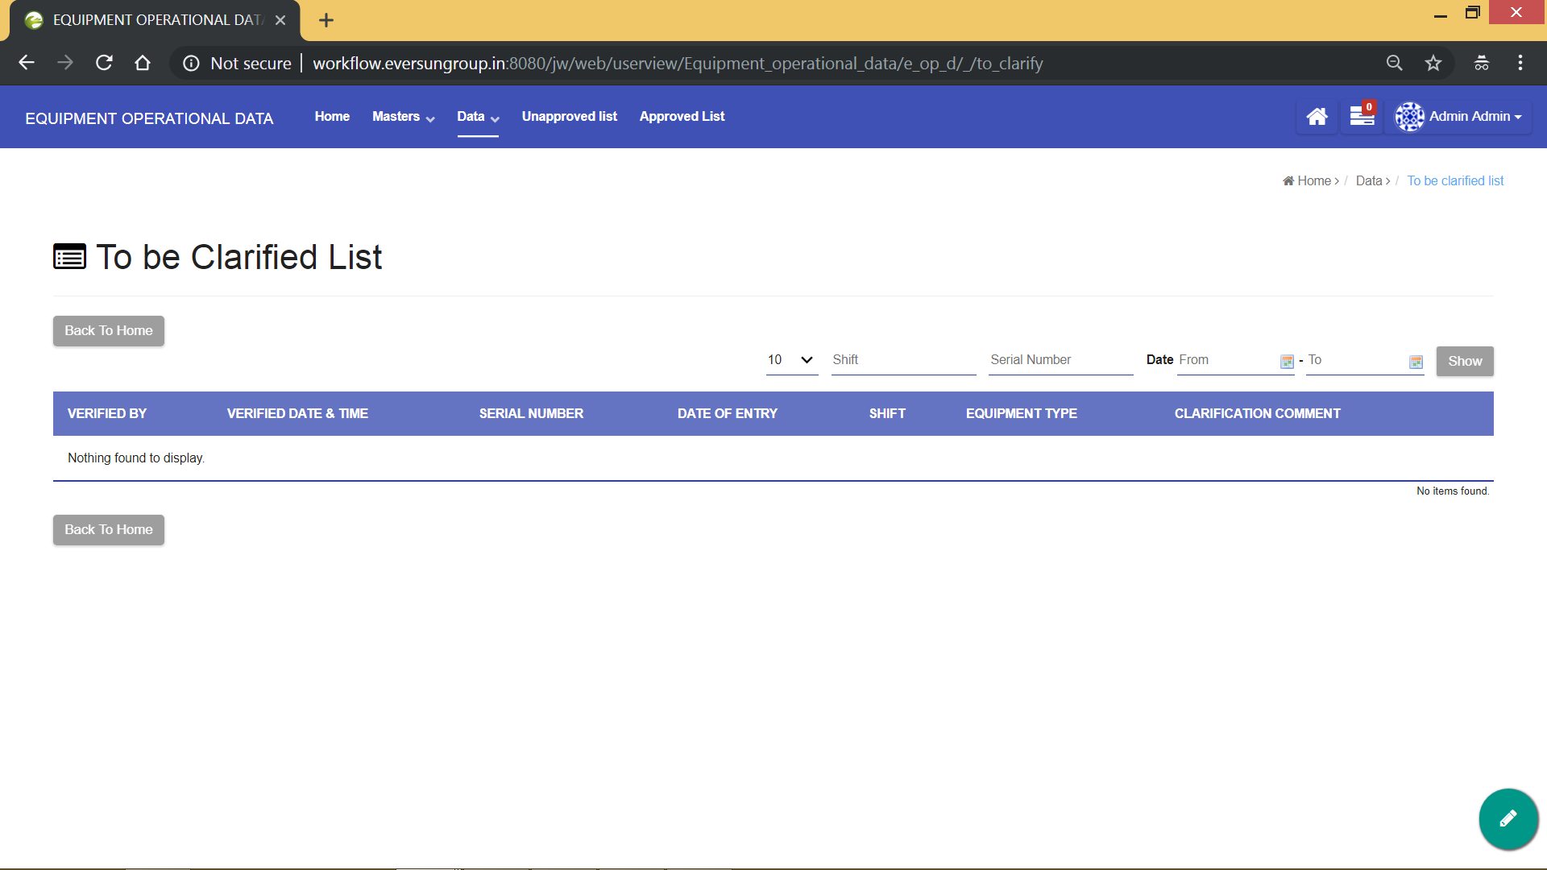

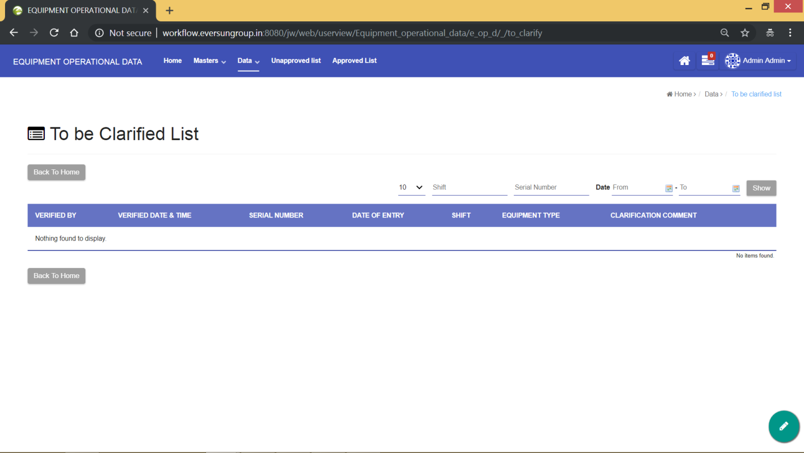

In the above page, you can do the following things

1. Clarify the existing data using **“Edit”** button, which is to the right of each data.
2. Go back to home page using **“Back To Home”** button, which is to the right of each data.
3. Search among the available entries, using the available filters on the top right corner of the screen.

The entry once clarified using “Edit” button is removed from this list and it is sent automatically to unapproved list.

**Forms and Datalists**

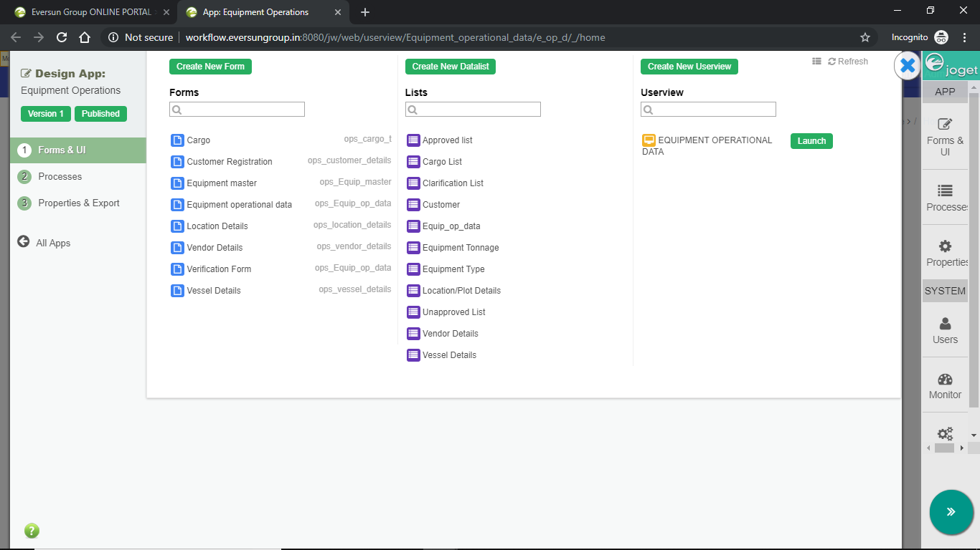

**Forms**

**“Cargo” form**

This form is used to register a new cargo into the cargo master.

**“Customer Registration” form**

This form is used to register a new customer into the customer master.

**“Equipment master” form**

This form is used to register a new equipment into the equipment master.

**“Location Details” form**

This form is used to register a new plot/location into the plot master.

**“Vendor Details” form**

This form is used to register a new service provider into the service provider master.

**“Verification Form” form**

This form is used to verify the entered operational data. Two operations can be performed in this form

1. Approve
2. Clarify

**“Vessel details” form**

This form is used to register a new vessel into the vessel master.

**Datalists**

**“Approved list” Datalist**

This list contains all the approved operational data whose status is set as “approve”.

**“unapproved List” Datalist**

This list contains all the unapproved operational data whose status is set as “completed”.

**“Cargo List” Datalist**

This list contains all the registered cargos.

**“Clarification List” Datalist**

This list contains all the operational data whose status is set as “clarify”.

**“Customer” Datalist**

This list contains all the registered customers.

**“Equip_op_data” Datalist**

This list contains all the entered operational data.

**“Equipment Type” Datalist**

This list contains all the registered equipments.

**“Location/Plot Details” Datalist**

This list contains all the registered plots/locations.

**“Vendor Details” Datalist**

This list contains all the registered service providers.

**“Vessel Details” Datalist**

This list contains all the registered vessels.